Tests with screenshots

# CSS validation

# CI Python Linter Test

## Model.py

**Before**

**After**

## Forms.py

**Before**

**After**

## Clients/urls.py

**Before**

**After**

## Clients/views.py

**Before**

**After**

## Settings.py

**Before**

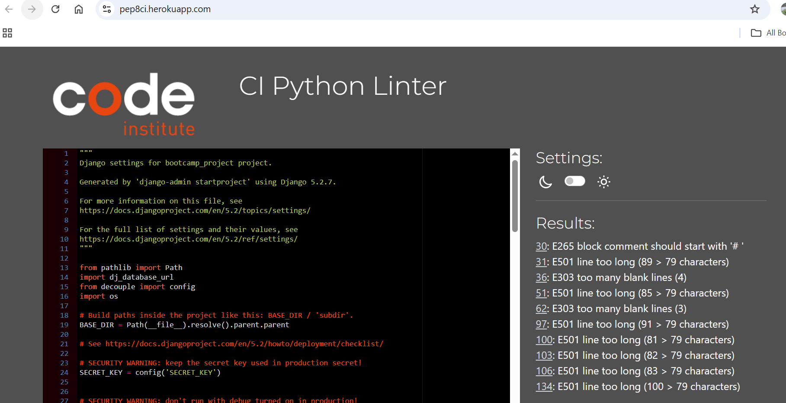

**After**

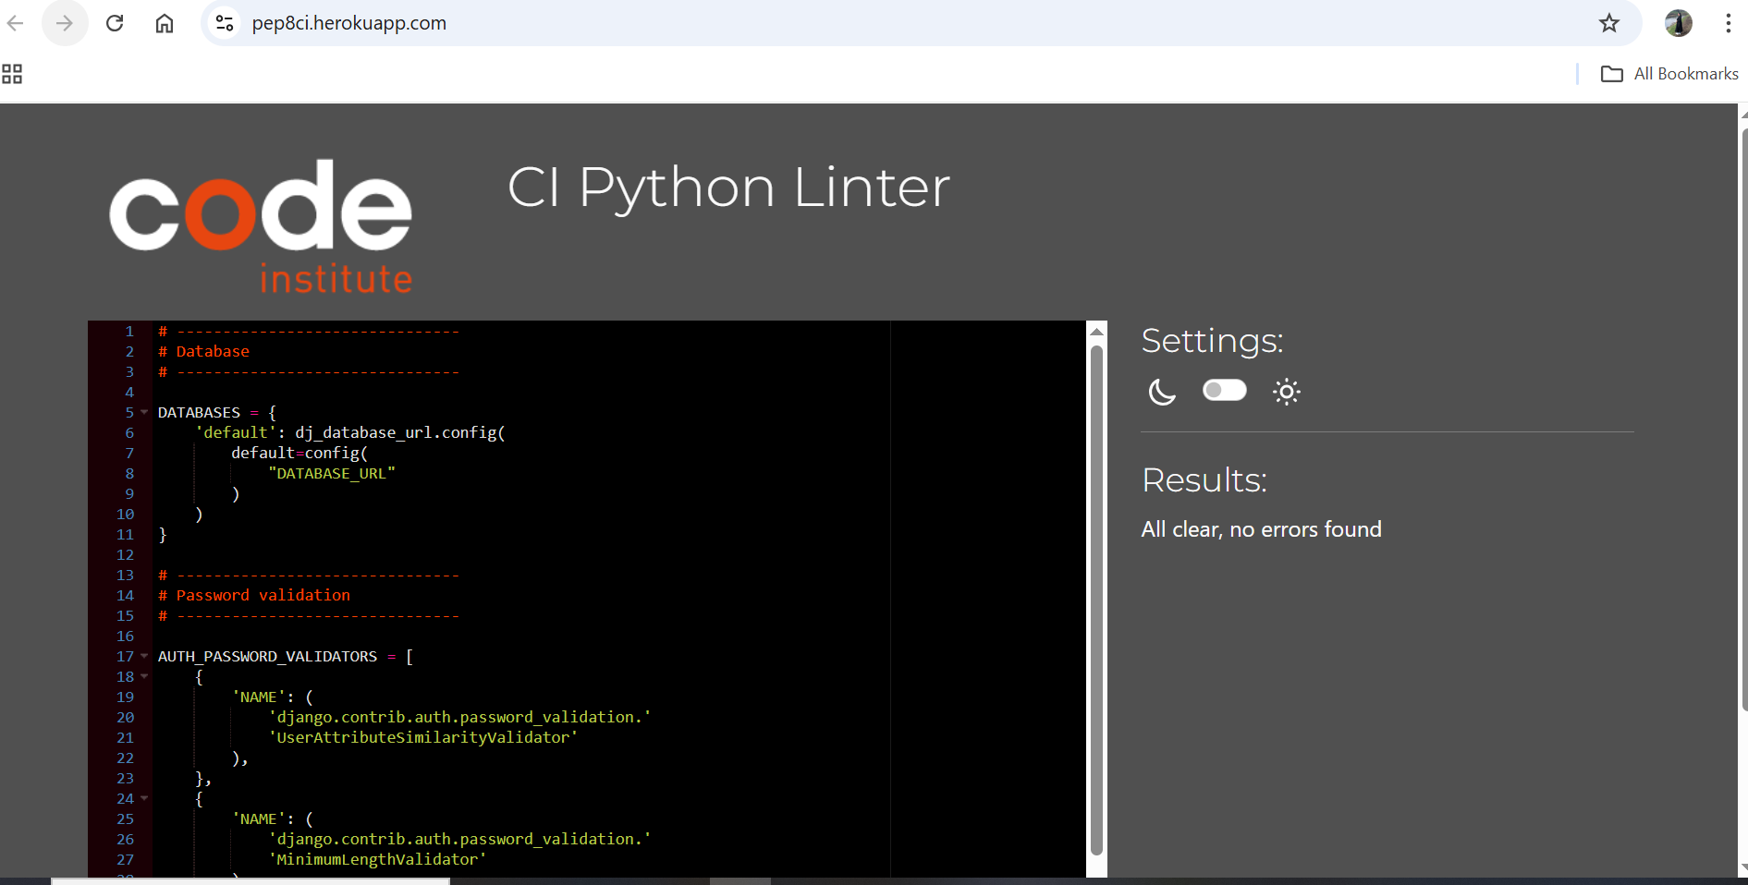

## Project/urls.py

**Before**

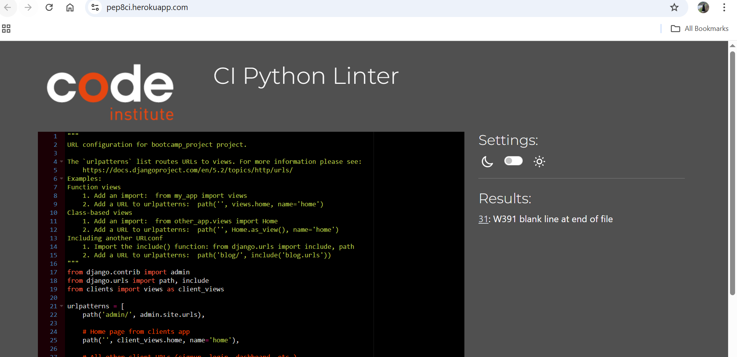

**After**

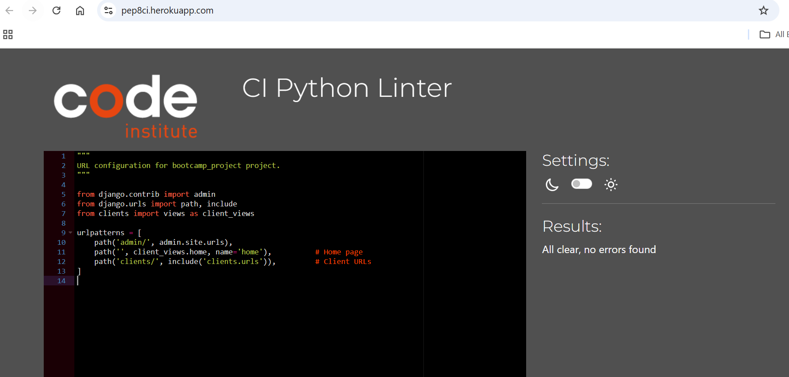

# User Interface

## Home Page

## Sign up page

## Sign up success notification

## Login page

## Client don’t see Admin button at the top

## Dashboard

## Edit Profile

## Book Appointment/Create

## Appointment created

## Edit Appointment

## Appointment Cancelled/ Deleted

## User Validation

Client cannot logged in as an Admin

## Client logged out and Client logged in

## Admin’s ability to Delete, Edit, Save and add new user

# Project Progress

# Responsiveness

## iPhone 12 pro

## Laptop

